**Lab Exercise 6– Terraform Variables**

**Objective:**

Learn how to define and use variables in Terraform configuration.

**Prerequisites:**

* Install Terraform on your machine.

**Steps:**

1. **Create a Terraform Directory:**

* Create a new directory for your Terraform project.

**mkdir terraform-variables**

**cd terraform-variables**

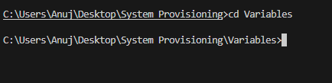

**2.Create a Terraform Configuration File:**

* Create a file named main.tf within your project directory.

**# main.tf**

resource "aws_instance" "myinstance-1" {

    ami = var.myami

    instance_type = var.my_instance_type

    count = var.mycount

    tags = {

      Name= "My Instance"

    }

}

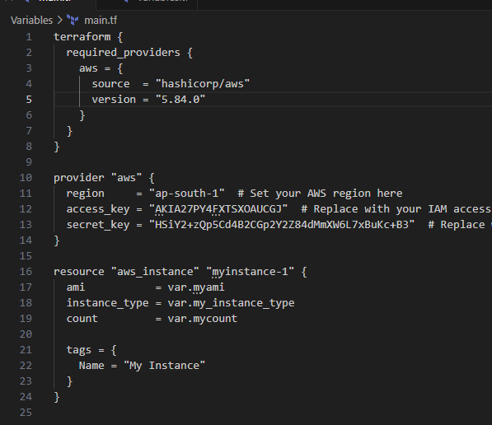

**2.Define Variables:**

* Open a new file named variables.tf. Define variables for region, ami, and instance_type.

**# variables.tf**

variable "myami" {



  type = string



  default = "ami-08718895af4dfa033"

}

variable "mycount" {

  type = number

  default = 5

}



variable "my_instance_type" {

    type = string

    default = "t2.micro"

}

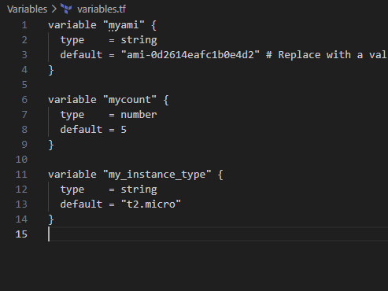

**2.Initialize and Apply:**

* Run the following Terraform commands to initialize and apply the configuration.

**terraform init**

**terraform plan**

**terraform apply -auto-approve**

Observe how the region changes based on the variable override.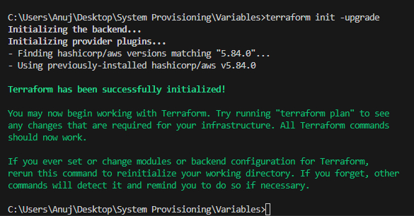  
  
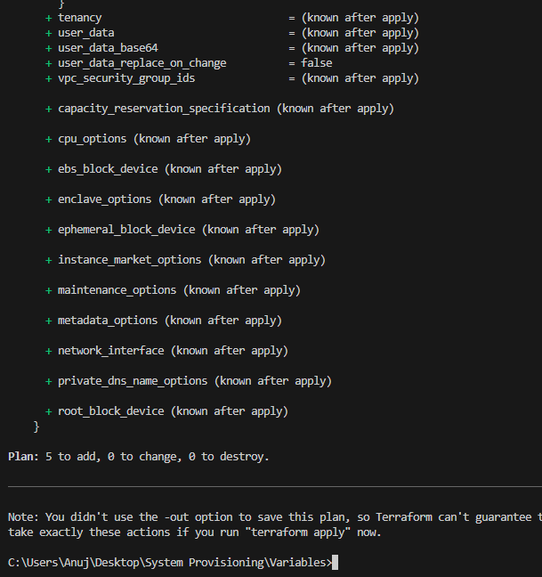

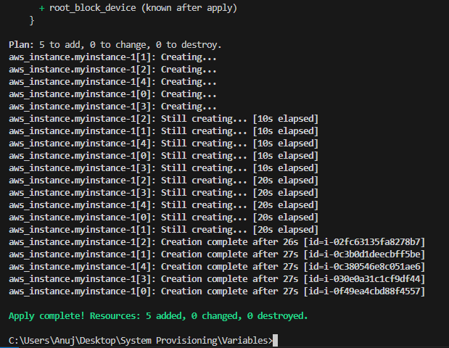  
  
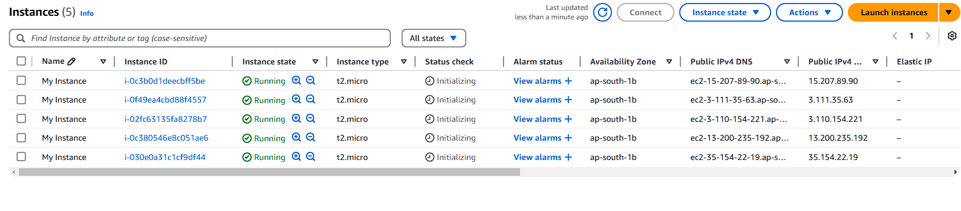

1. **Clean Up:**

After testing, you can clean up resources.

**terraform destroy**

Confirm the destruction by typing yes.

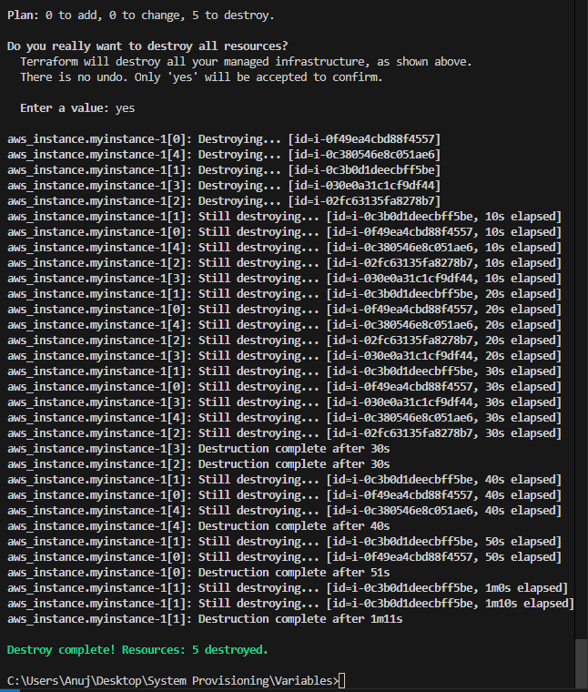

1. **Conclusion:**

This lab exercise introduces you to Terraform variables and demonstrates how to use them in your configurations. Experiment with different variable values and overrides to understand their impact on the infrastructure provisioning process.